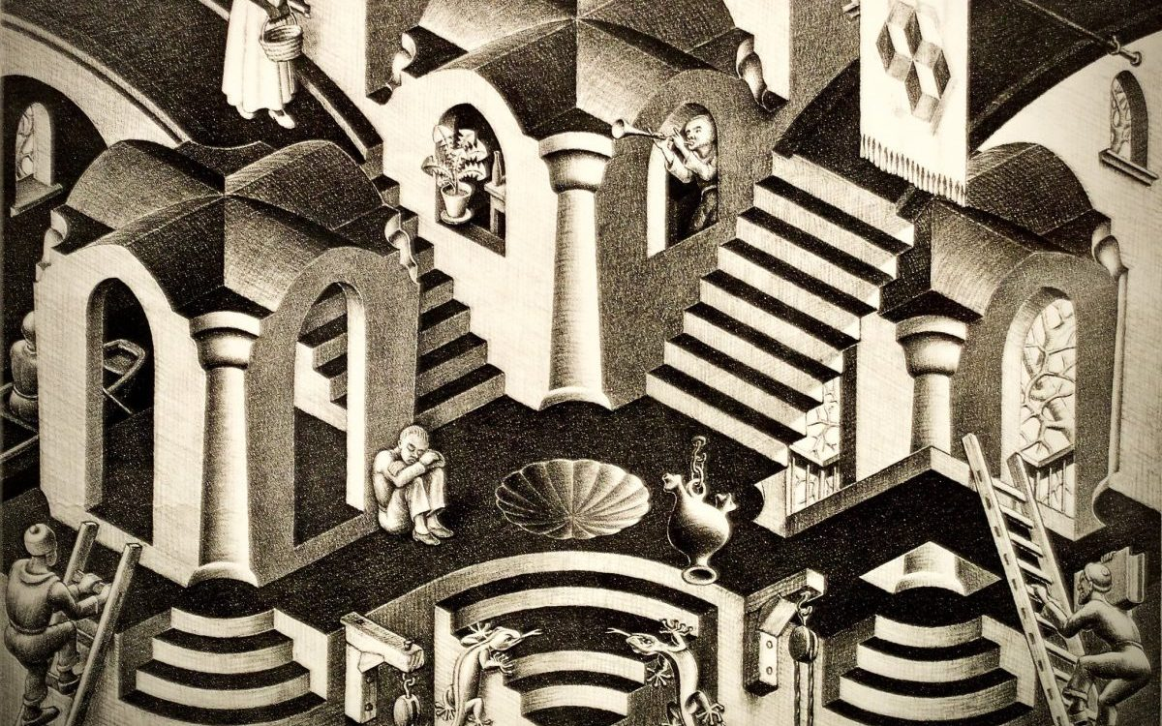

Algorithm Design & Data Structures.
  - Assignment report.
dak55@| CS21120 | 11/9/2025

Task 1

The Data Structure.
The museum is represented using a graph structure in which each room is a vertex ( roomVertex ), and each doorway is an edge ( edge ). Rooms are stored in a Map ( rooms ) which allow for constant look-up times by room name. Each room contains a Map to represent outgoing edges keyed by the direction by which the edges lead to.
Using such a structure offers clear advantages:
- The maps allow for O (1) room Look up, which provides us with fast neighbor access as well.
- The map also prevents invalid connections, as only cardinal directions are accepted.

Generating the Museum.
Using the help of smaller Helper methods, I opted to hard code the museum generation rather than use an intermediate representation.
2 Helper methods were used in its generation.
- createRoom – creates a room Object and inserts it into the rooms map.
- connectRooms – adds bidirectional edges between the two rooms.

Walk method.
The walk method makes use of previously used logic in earlier assignments; by using a while loop and prompting the user to input in which direction he would like to navigate the museum, The loop contains input validation to ensure that only valid cardinal directions are accepted, and movement only occurs if a valid edge exists.
Another important aspect was normalizing the direction string, early into the development of this method I ran into many bugs since I didn’t accommodate the code to accept the directions written with inconsistent capitalization, which led me to normalize all inputs using the toLowerCase method. This logic was later reused in the get Connection method as well.

get Connection Method.
The get Connection method retrieves the width of a doorway connecting two rooms in a specified direction. There were 3 key responsibilities for this function to perform.
- Ensuring the input of rooms and direction is correct.
- Lookup of outgoing edge and the verification of destination.
- Like the walk method an important aspect as normalizing the direction string.
Another important responsibility of the function was the implementation of defensive error handing such as throwing an exception when a room name does not exist or when the direction is invalid. To implement such features, I used a series of simple ‘if’ statements.

Task 2: get Mermaid ().
The getMermaid method is responsible for the textual representation of the museum’s structure in a mermaid format. I opted to automate this method rather than hard code it.
To support this, first I implemented a helper method inside the roomVertex class. This method iterates over all the outgoing edges for the vertex and appends the appropriate syntax for each connection. I used the String Builder for this process because it allowed appending the syntax much more efficiently rather than using repeated string concatenation.
In the main getMermaid Method I once again used a StringBuilder for the same reasons. Here I loop over ever room stored in the rooms map and call the helper method to gather the edges in its correct format; then the mermaid string would be outputted to the Terminal and Copied into the live mermaid editor for visual testing.
What made this method challenging was not the algorithmic logic but the strict formatting required or mermaid to properly interpret the text, many of my early version produced logically sound connections yet the diagram failed to render properly dude to small syntax issues such as incorrect line breaks spaces, Another major difficulty was preventing duplicate edges in the graph, since the museum is bidirectional, my early version produced two lines for every corridor, this cause mermaid to generate multiple identical arrows making the Diagram look messy.
To solve this problem, I introduced an alphabetical check in the helper method, The room only outputs an edge to the string if its identifier comes before the destination rooms identifier alphabetically, this ensures each connection is only written once.
In terms of complexity, the best, worst and average cases are all O (R + E) where R is the number of rooms and E is the number of edges, this is because the algorithm must always perform a full traversal of each of the rooms and their respective edges to draw the connections.
This is the expected output of The Diagram in the mermaid Live editor. 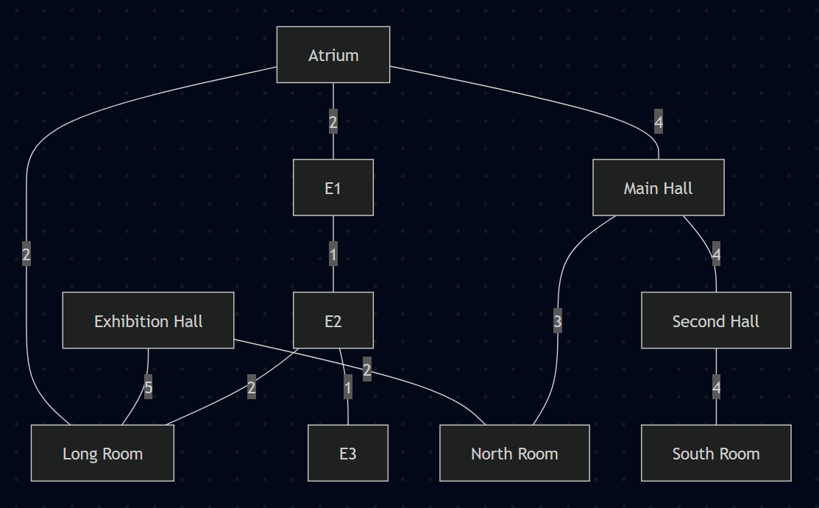

Task 3: hasValidPath ().
The hasValidPath method checks whether two rooms are connected by a route whose doorways all meet the minimum width, I implemented this using a recursive DFS, DFS was chosen because the task only needs checking if a valid path does not exist, finding the shortest path, so BFS provides no advantage over DFS in this situation. Recursive DFS also offered cleaner backtracking and simpler code compared to an iterative approach. I used a helper method, traverse, which performs the recursive exploration and is called inside hasValidPath, following the structure used in earlier practical work.
One difficulty was handling cycles, to handle this I introduced a visited set, which ensures each room is only explored once per search. This method also includes basic validation to ensure that the room we are searching for exists.
In terms of efficiency the time complexity for this algorithm is O (R + E).

Task 4: Allocating Exhibits to Rooms.
This task required updates to my Data Structure, I opted to use a dedicated class for representing the exhibits, and like how I store edges inside nodes, in the form of a map, I reused that logic and stored the exhibits the same way; with the key being its name, and the value an exhibit object. Inside the Museum class I added Another Map to store all the exhibits in, like the rooms map. The worst-case complexity for inserting, deletion, and lookup on this structure is O(n).
Allocation was done using recursion with size-based heuristic ordering. Before the allocation, exhibits and rooms are copied into temporary lists and sorted in descending order of exhibit Size. This ensures the algorithm attempts to place the largest and most restrictive exhibits first, reducing branching.
The logic for this method was split into 4 helper methods.
- generateExhibits -> Reads exhibit data from the CSV file and declares exhibits.
  - String splitting Logic was reused from my CS12320 assignment.
- exhibitAlreadyAllocated -> this method loops through all rooms and ensures the current exhibit is not inside any of the nodes’ exhibit map.
- allocationIsValid -> this method contains all the checks to ensure all constraints are met before allocating an exhibit to a room.
- recursiveAllocator -> This method implements the actual recursive backtracking process, I try to allocate the current exhibit to each room in turn, but only if it passes all constraints. After placing an exhibit, it moves on recursively to the next one, if a later placement fails the previous placement is undone.
The most difficult part of this task was the backtracking and correctly undoing the placement of the exhibits, initially my backtracking implementation failed because when an allocation was valid, I would place the exhibit in the room then remove the exhibit from the parameter list, I didn’t realize that changing the list affected the recursion which completely broke the logic. To fix this I opted to use a separate list for the recursion which contains the exhibits which have not yet been placed in a room so there is no need for me to change the parameter list.
Time complexity.
Let n be the number of exhibits and m the number of rooms.
- Validity checking for one placement takes at worst O(k) where k is the number of exhibits already in that room.
- The backtracking algorithm tries each exhibit in each room in the worst case, giving a worst-case complexity of O(mⁿ).

Testing:
3 Separate Classes were used for testing.
- testMain -> used to Check the mermaid output is correct.
- MyTask1Tests -> A series of Junit Test for the First Task
- Task4Tests -> A series of Junit Tests for the Fourth Task
All details of what I test for is mentioned in comments inside the test classes.
Reflection on process of Development.
Looking back at my process of development for this assignment I believe that I have learnt mean valuable lessons.
It made me realize that I struggled with coding fluency, in many instances I found myself stuck not knowing what to write in the IDE even though I understood what needed to be done in theory.
Initially I struggled quite a bit with the data structure, as well as the mental shift of using Map instead of Lists; A lot of the time I found myself using List methods on Maps and Iterating over a map as if it’s a list which made me run into many bugs.
The biggest Hurdle for me was working on the final task and testing it, I feel like I didn’t produce high enough quality code for this section compared to the other tasks, I believe that the code could have been more organized. It made me realize the gap in my knowledge when it comes to recursion and made me realize I need more practice evaluating algorithm behaviour, I found myself having to revise how recursive backtracking is handled too frequently.
It also helped me shift my thinking from coding in a way that “Just Works” into What is more efficient; An example of this is using Maps instead of basic lists which reduced the number of times I had to resort to brute forcing an algorithm.
Despite these difficulties, I believe that I did a decent job on this assignment, my code was clear and so was its structure although I believe I could have tested my 3rd and 4th task more extensively; I also believe that my report was very simple yet informative of the development process for my project. Overall, I’m pleased which the way the assignment development process went.

Reference list

Learning Material for Junit.
Bechtold, S. (2016). JUnit 5 User Guide. [online] Junit.org.
Coding with John (2025). JUnit Tutorial. [online] Youtu.be. Available at: https://youtu.be/vZm0lHciFsQ?si=tw-ifhqQeqYRvLBH
Material for familiarizing with mermaid syntax.
Mermaid (2025). Mermaid Flowchart Documentation. [online] Mermaidchart.com. Available at: https://docs.mermaidchart.com/mermaid-oss/syntax/flowchart.html
Documentation used as material for learning StringBuilder.
Oracle (n.d.). StringBuilder (Java Platform SE 8 ). [online] docs.oracle.com. Available at: https://docs.oracle.com/javase/8/docs/api/java/lang/StringBuilder.html
W3Schools (n.d.). Java String replace() Method. [online] www.w3schools.com. Available at: https://www.w3schools.com/java/ref_string_replace.asp
References for Algorithms and Data Structures Used
Zagres, C. (n.d.). CS21120 Recursive Algorithms. Lecture 4, Workshop 2. [online] Aberystwyth University.
Zagres, C. (n.d.). CS21120. Maps and Sets (Abstract Data Structures), Lecture 5. [online] Aberystwyth University.
Zarges, C. (n.d.). CS21120. Graph Data Structure and traversal. Lecture 9, Workshop 5. [online] Aberystwyth University.

